Objective: to Grow existing Disks from 400G to 800G

Bob Gura does re shuffle on Storage side first and then let us know so we can start Resize and Remove steps.

If this work done on StandBy side need to stop log apply first!!

If this Primary shutdown database.

Select +ASM

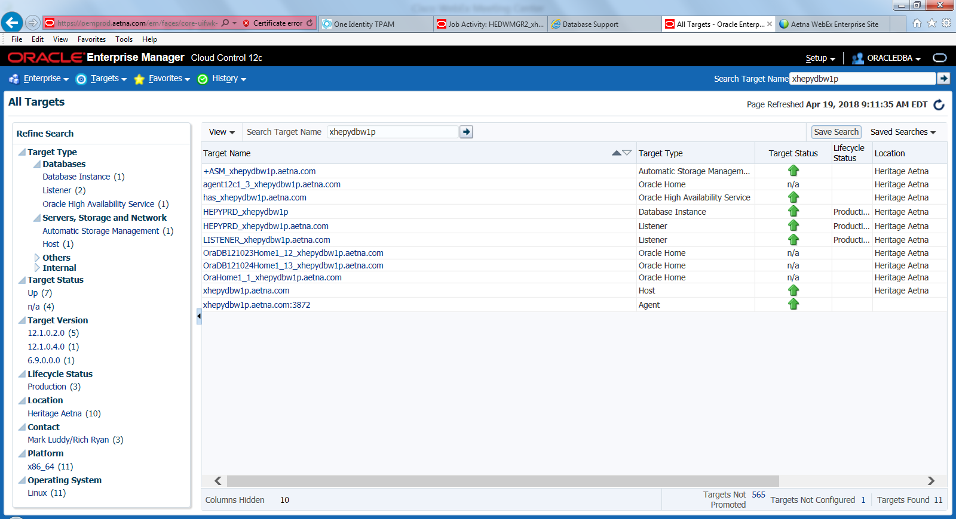

Select Disk Groups see below

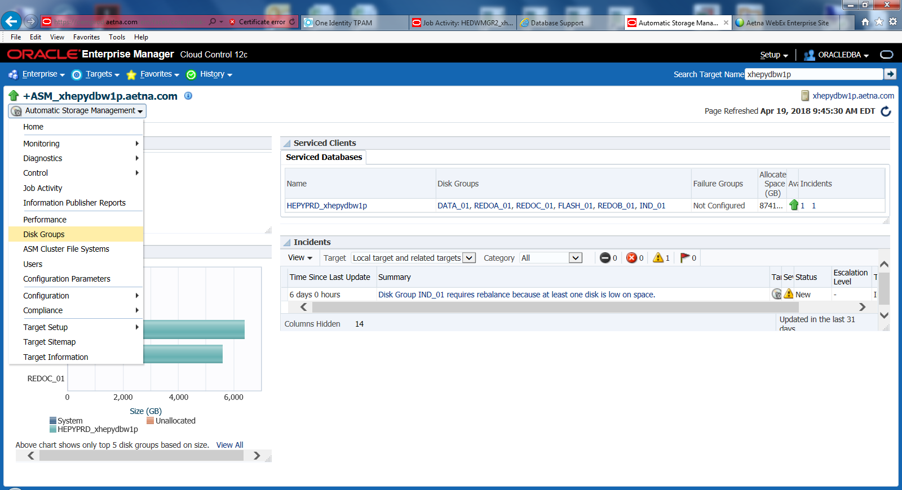

sys as sysasm

SYSASM

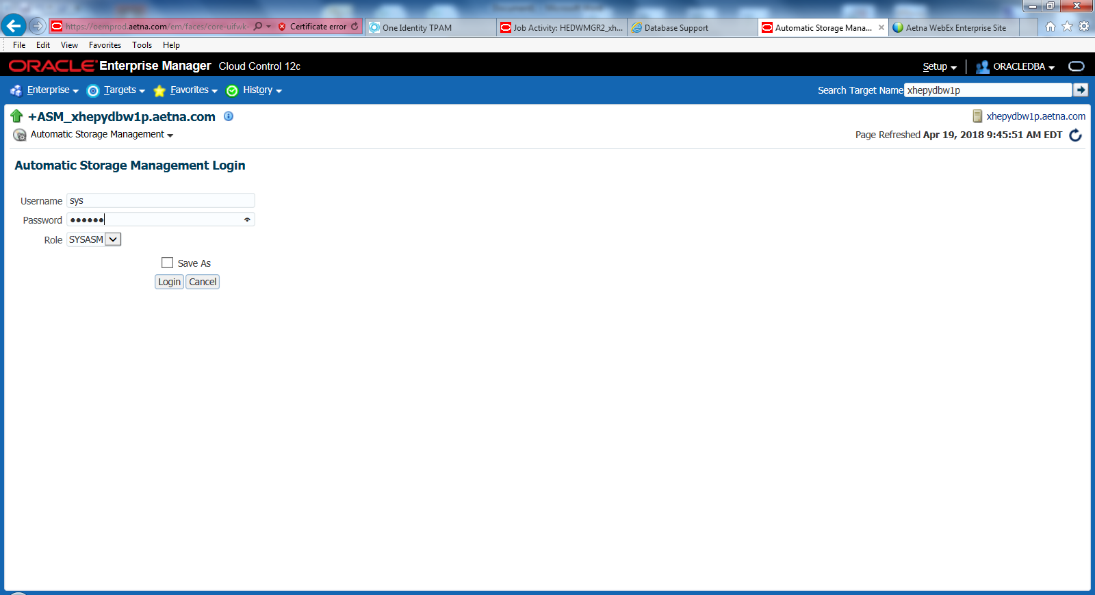

Drill down to particular Disk by click on Name (IND_01 or DATA_01)

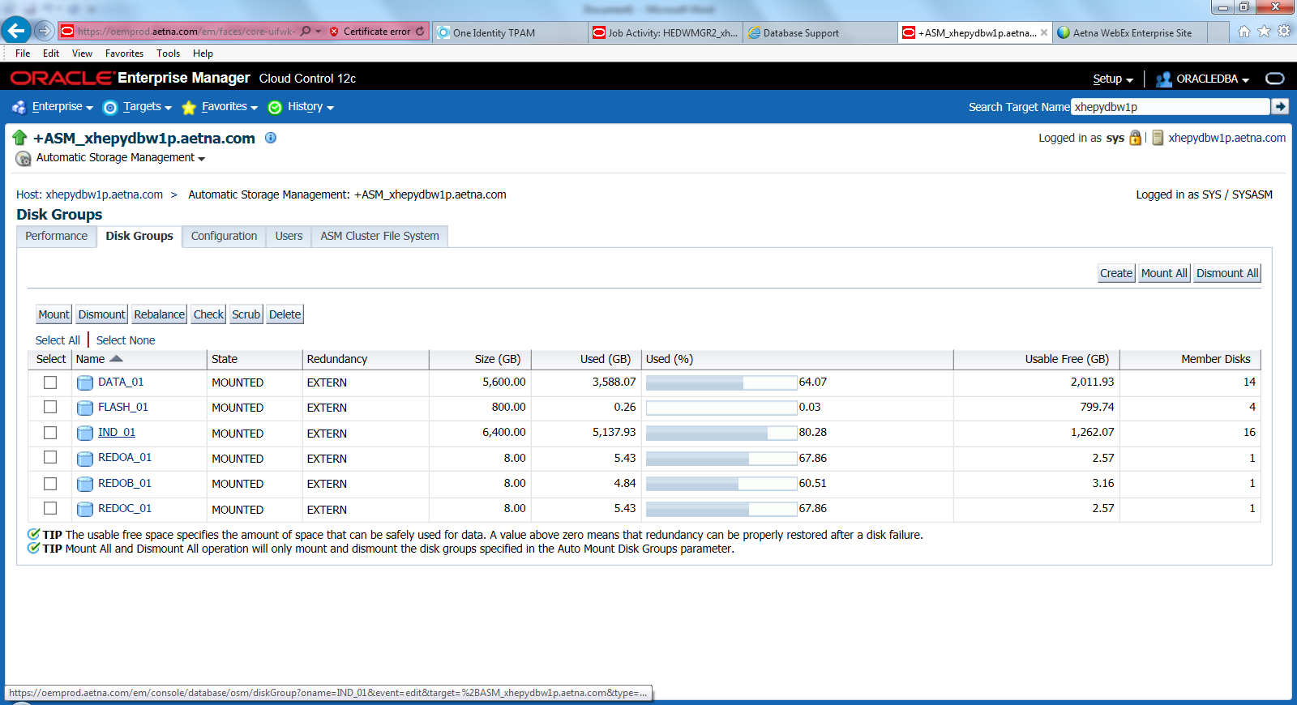

Select Disk or several Disks and click Resize button. (Ask Bob Gura which one)

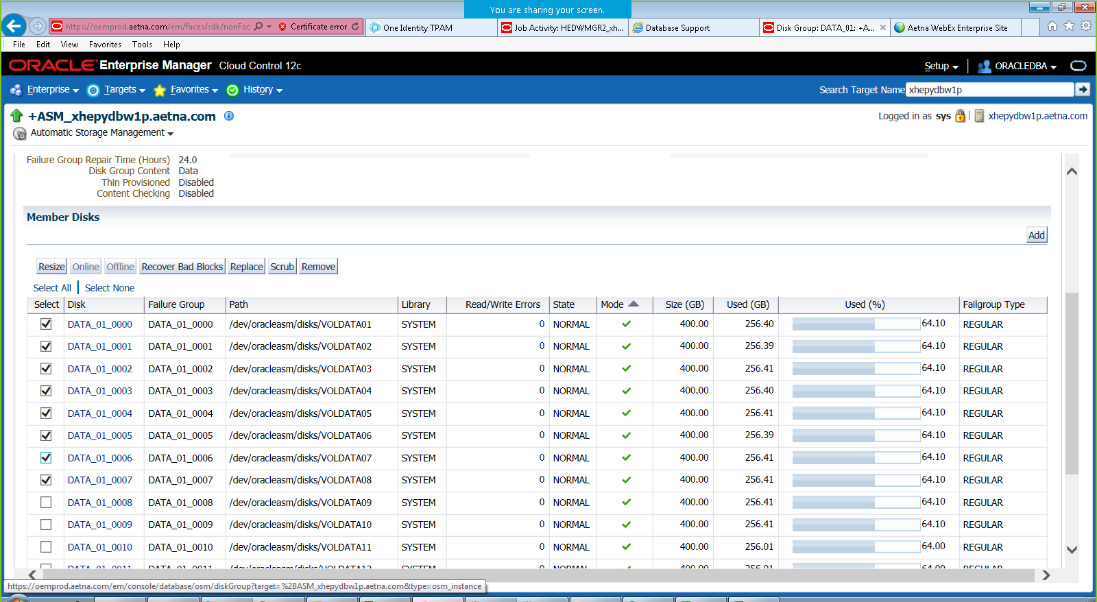

|  |  |
| --- | --- |
| |  | | --- | |  | |

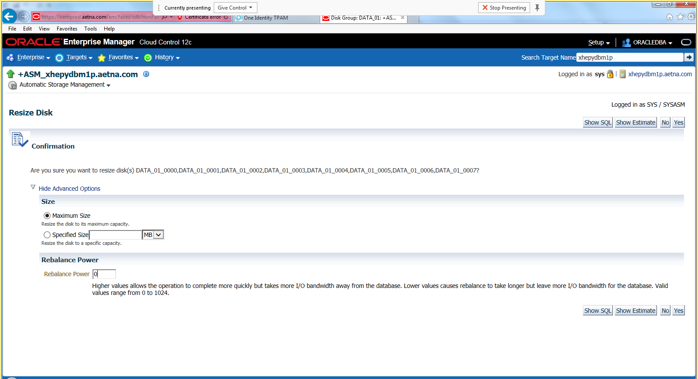 





Show SQL



**ALTER** DISKGROUP DATA_01 **RESIZE** DISK DATA_01_0000 DISK DATA_01_0001 DISK DATA_01_0002 DISK DATA_01_0003 DISK DATA_01_0004 DISK DATA_01_0005 DISK DATA_01_0006 DISK DATA_01_0007;

Select Advance Option and put power 0 (I will not do rebalance on resize it will do it during later step)

Click Yes

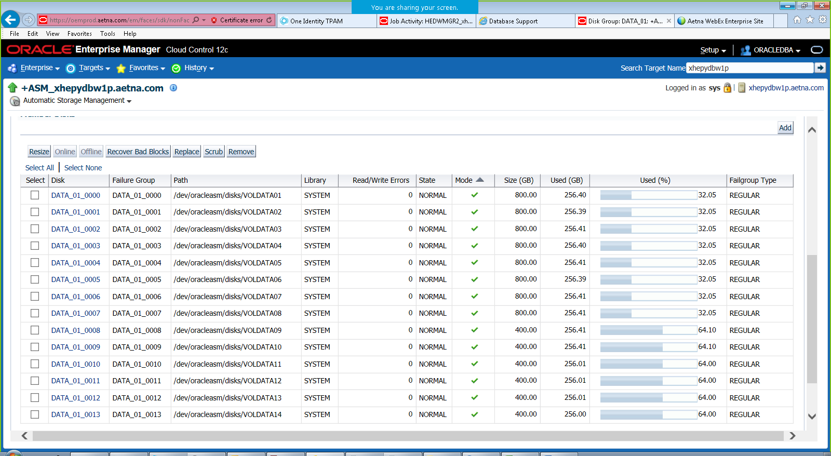

Select disks not sized and click Remove see below

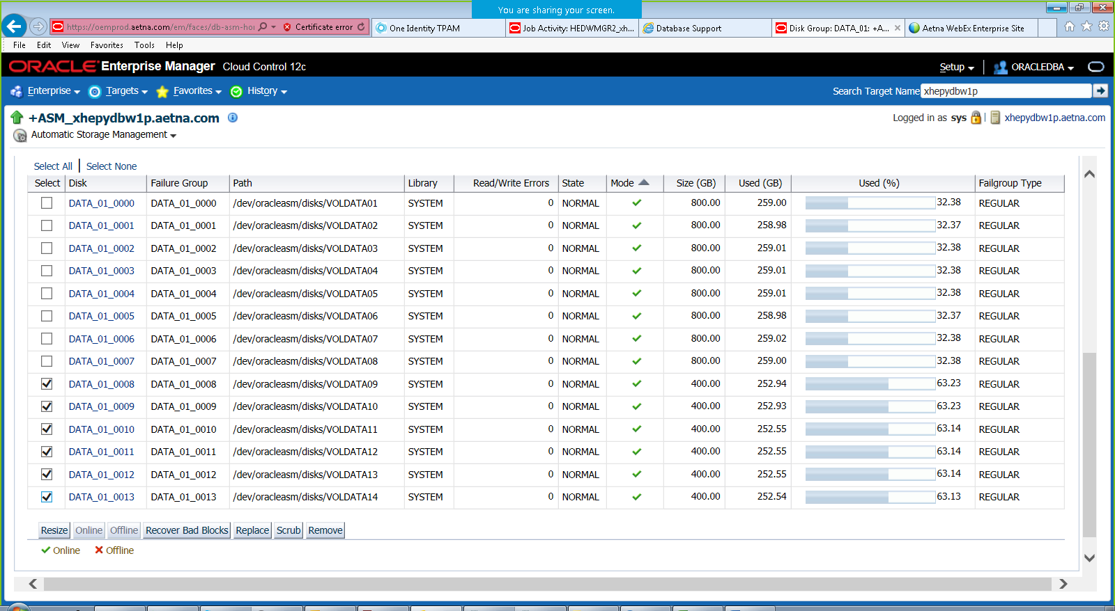

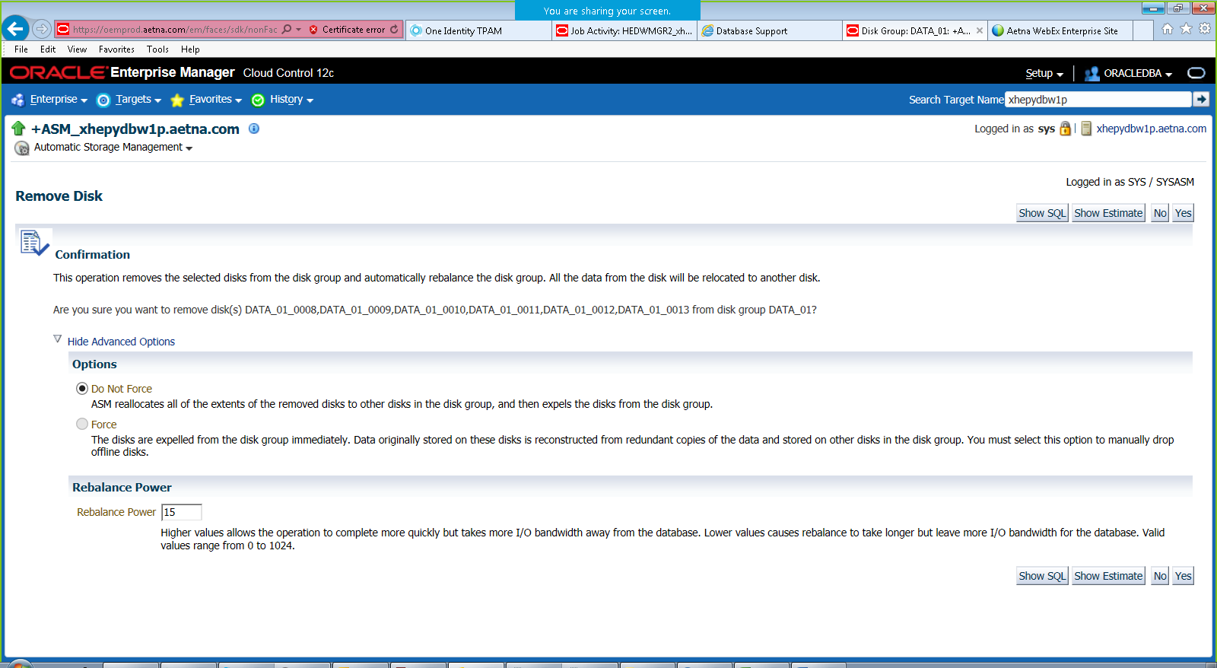

Click Yes

Show SQL

**ALTER** DISKGROUP DATA_01 **DROP** DISK DATA_01_0008 DISK DATA_01_0009 DISK DATA_01_0010 DISK DATA_01_0011 DISK DATA_01_0012 DISK DATA_01_0013 REBALANCE POWER 15;

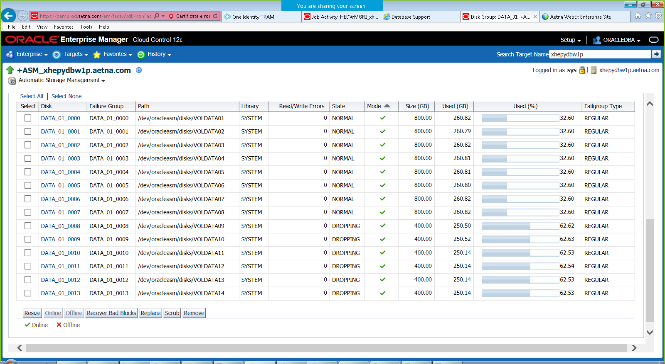

Keep refreshing it may take some time, but bars on DROPPING disks will be moving eventually. You can run query from +ASM

cd $SQLPATH

sqlplus / as sysdba

select OPERATION, pass, STATE, POWER, ACTUAL "ACTUAL POWER",SOFAR, EST_WORK, EST_RATE, EST_MINUTES from V$ASM_OPERATION;

or

@asm_rebalance_progress.sql

**Once all completes run below to verify that Dropped DISKs have 0 data.**

SET LINESIZE 145

SET PAGESIZE 200

SET VERIFY off

select

MOUNT_STATUS ,

HEADER_STATUS ,

TOTAL_MB ,

FREE_MB ,

substr(NAME,1,20) "Name",

substr(LABEL,1,10) "Label",

substr(PATH,1,50) "Path"

from

v$asm_disk

order by

path,

name

;

**Or**

cd $HOME/tls/space

get_asm_space.sh HEPYPRD

**Repeat all above for INDX**